Q.1)Get backup of AMI instance on daily basics interval of 12 hrs in any scipt

Step 1:- We need to lanuch instance in aws on this instance have role to access ec2-service

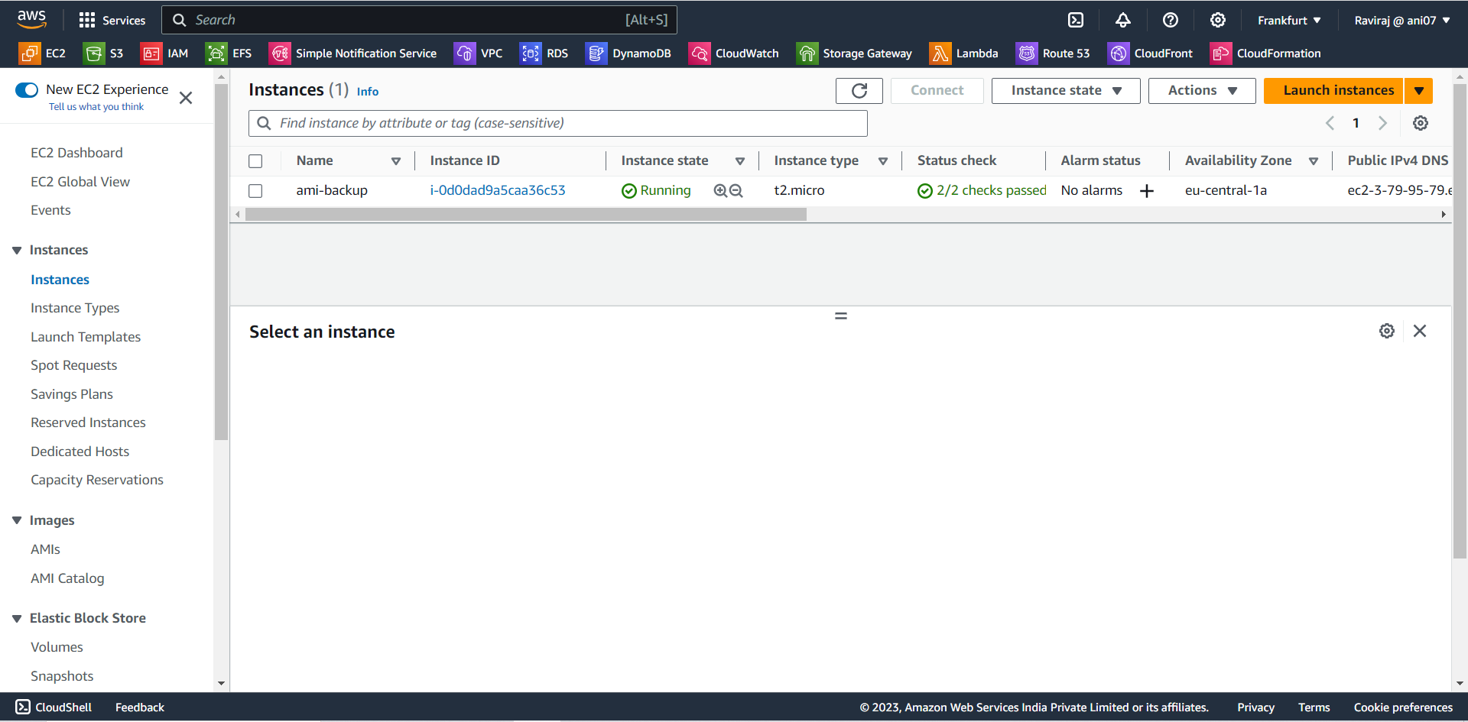

Step 2:- We creating sh script to get daily basis back-up to create sh file need to get access of launched instance on bash shell open bash from ssh key location

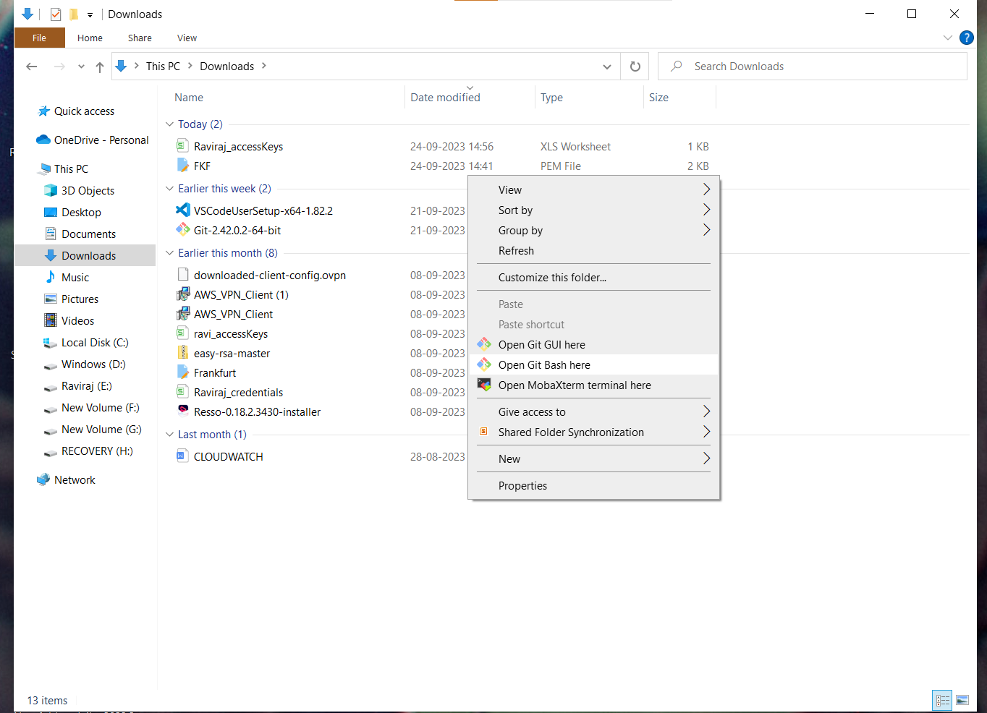

Getting access then write scrip

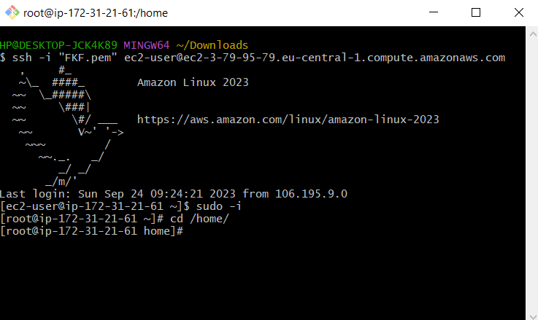

Entering scrip in vim file name ami-backup.sh

Grant permission execution to sh file

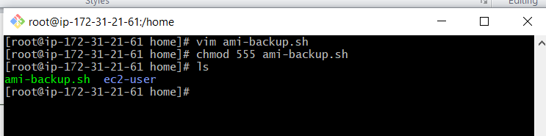

We need to enter in script

1. access key id

2.secret accees key

3.region

4.instance ID

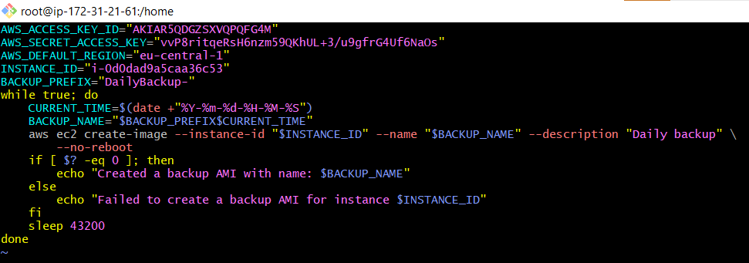

Then save the file .

Step 3:- Now schedule crontab for that install crontab on bash then start service 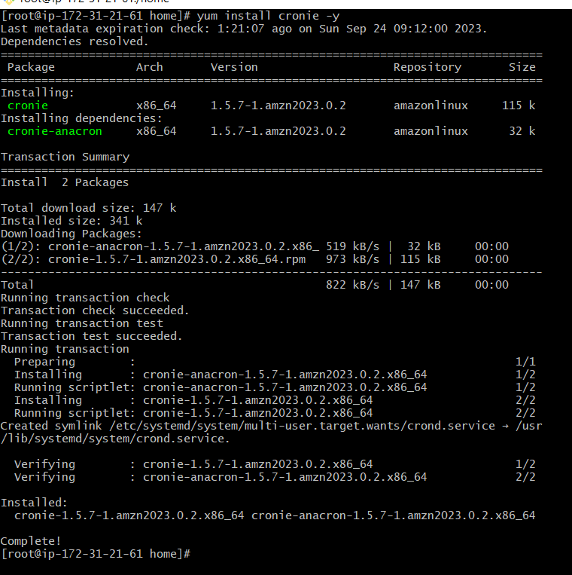



Now ami-backup.sh file run auto matically on daily basis 12 hours interval

Backup of ami image available in AMIs

